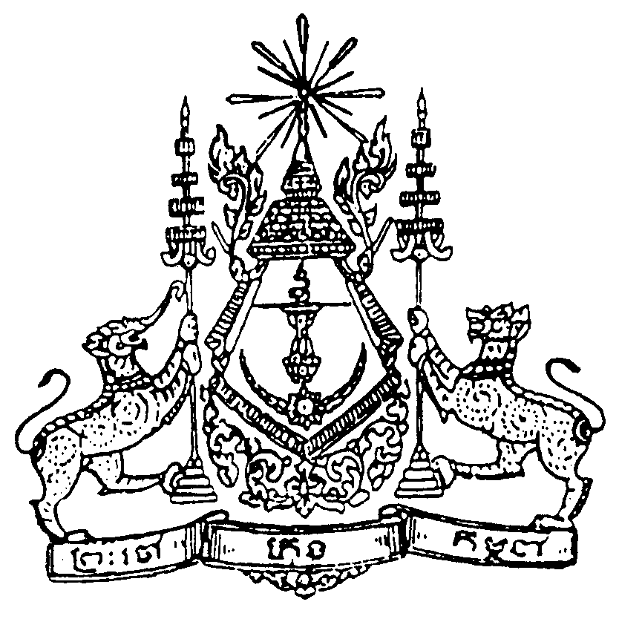

Kingdom of Cambodia
Nation – Religion - King

Address

by
Samdech HUN SEN

Prime Minister of the Royal Government of Cambodia
At the

United Nations General Assembly

New York
(Monday, 15th September 2005)

Majesties,
Excellencies, Heads of State and Government
Mr. Jan Eliasson, President of the General Assembly
Mr. Secretary-General
Distinguished Delegates

On behalf of the delegation of the Kingdom of Cambodia and my own, I would like to extend our congratulations to H.E. Jan Eliasson on his election as the President of the 60th session of the UN General Assembly. Allow me to express also, my appreciation to H.E. Mr. JEAN PING, President of the 59th UN General Assembly, for his able leadership and guidance.

The excellent report, "In Larger Freedom", of H.E. Mr. Kofi Annan, UN Secretary General, and his colleagues provides a global vision and proposals for us to build together human solidarity through a more just and civilized world. Our actions today will determine the destiny of humanity and our planet.

Cambodia has turned a new page in its history, putting firmly behind the darkness and tragedies of recent past and has emerged into the new dawn of its future. Democracy has taken strong roots, public order and rule of law have made steady and tangible progress, human rights are fully protected and spectacular economic growth is manifestly evident. We have also made significant advances towards reaching Cambodia's Millennium Development Goals, especially in the education sector and in combating HIV/AIDS. We however know that in socio-economic development, the road ahead is longer and more arduous than we have so far covered. At present, the Royal Government of Cambodia is actively preparing the “National Strategic Development Plan” for 2006-2010, which will determine Cambodia’s milestones towards achieving the MDGs in 2015.

Allow me to raise some issues related to the future of our fragile world in the 21st century.

I. Freedom from want
We fully share the Secretary-General’s analysis of the inter-linkages between human rights, the rule of law, democracy, security and development. We should therefore work on all the fronts at the same time. Unless all the inter-dependent causes advance, none can succeed.

Development issues should remain at the heart of the attention of the international community. Strong political will is a prerequisite to achieve the MDGs. A global partnership between rich and poor countries should be based on mutual respect and trust, shared responsibilities and transparency. Aid-providing nations and institutions must move rapidly to make into reality the rhetoric of Paris and Rome Declarations by strictly and stoutly supporting full ownership of the receiving nations of both the process and priorities of socio-economic progress. Politically driven hidden agendas and shifting ideologies to bring coercive influence on the recipients must end. They serve only to "punish the poor". In fact, while the trend is declining, there is an increase in conditions linked to the aid. Most of aid were not delivered to the real poor, as a large amount of aid has been paid for the technical assistance and studies and also go to some sectors which are not consistent with development priorities of recipient countries. Aid has been given to meet the requirements of the donors, and at the end most of the aid money has been ploughed back to benefit the economy of the donor countries or to benefit consultants from other countries even though they are incompetent or do not know the recipient countries. At the same time, developing countries should take steps to carry out reforms, especially in the areas of domestic revenue mobilization, strengthened governance and the fight against corruption.

We welcome the decision of the G-8 nations to write off debts of 18 highly indebted poor countries to the amount of 40 billion dollars. However, this is merely a rescue rather than a solution. Successful development requires more net transfer of resources for real investments in poor countries in the form of grants, which are on the decrease from year to year. Moreover, the modalities should be flexible to enable poor countries to use loans to implement some projects that are of great benefit to their national economy, that have the capacity to generate high domestic revenue, while they do not affect their repayment capacity and macro-economic developments. We also need to move rapidly away from producing volumes of paper reports to providing relief or development assistance to the poor. The great spirit of the Monterey Consensus to increase ODA up to 0.7% of GDP must be translated into reality in real implementation. A fair trade system between developed and poor countries must become reality, so that the poor countries can fully use their own potentials and maximize their comparative advantages for growth.

We welcome the goals of the International Conference on Population and Development of achieving globally the reproductive health services before 2015. In the context of ensuring sound environmental governance, Cambodia welcomes the promulgation of the Kyoto Protocol aimed at stabilizing the emission of green house gases.

II. Freedom from fear

Terrorism constitutes a serious threat to any progress. It not only destroys the gains and puts the clock back, but diversion of scarce resources to combat it also robs resources for investment to meet development challenges to move towards a better tomorrow for all. As we take strong measures to combat and curtail it, we should at the same time address its root causes. We should put an end to the conditions that terrorists have exploited. We should remove the frustrations of the poor and excluded people living on our planet; restore dignity to those who feel they have lost it; and ensure that dialogue and cooperation prevail between civilizations, cultures and religions. It, in essence, is to lead a balanced and tolerant life, in adjustment and harmony with oneself, with one’s neighbors, with other beings, with nature and with the cosmos.

In closing, I would like to reiterate that the challenges of our time require political actions born out of intelligence, courage and heart. Cambodia stands ready to join in this global effort which will lead us on the path of development, security and freedom.

I thank you all for your kind attention!

